## DP Map

Interactive Design Document

Version: 3.0

Date: 10/06/2018

Presented by: DP Map Team

|  |  |
| --- | --- |
| Team Member 1’s Name | Nathan Cramer |
| Team Member 2’s Name | Pierson Beckman |
| Team Member 3’s Name | Manuel Harvey |
| Team Member 4’s Name | Cameron Faubion |

# **Revision History:**

Revision 1: add wireframe images.

Revision 2: add wireframe description.

Revision 3: add storyboard.

Revision 4: Add detailed design and design rationale.

# 2. Conceptual and Intermediate Design

## 2.1 Sketches and Storyboards

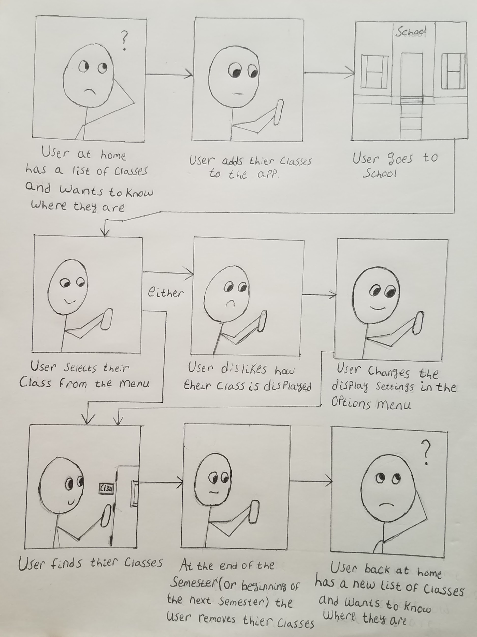

## 

## 

## 

## 

## 

## 

## 

## 2.2 Wireframes

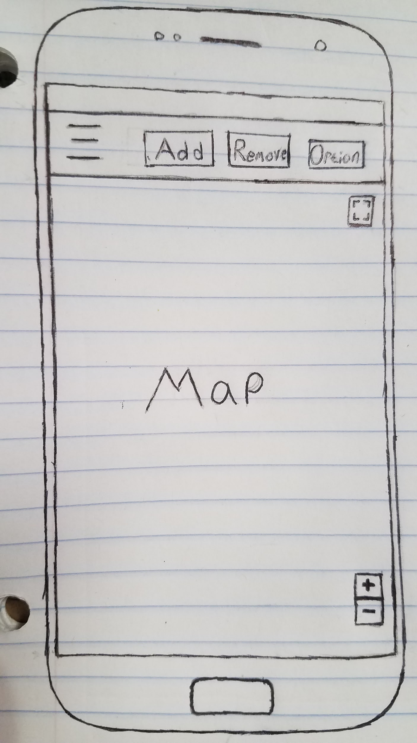

← This is the Wireframe for the main page of the app. The user will see this page when they start up the app.

The three horizontal lines will act as a dropdown menu for a toolbar that contains their list of classes. in the toolbar, the user will be able to select a class to highlight or pin its location on the map.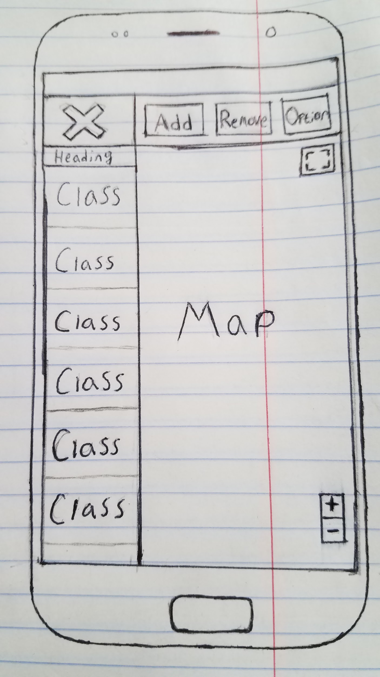

The image on the right shows what this toolbar will look like.

The little buttons on the right side of the map box are optional and will be added to support zoom functions or full screen support if they are deemed necessary in later iterations of development.

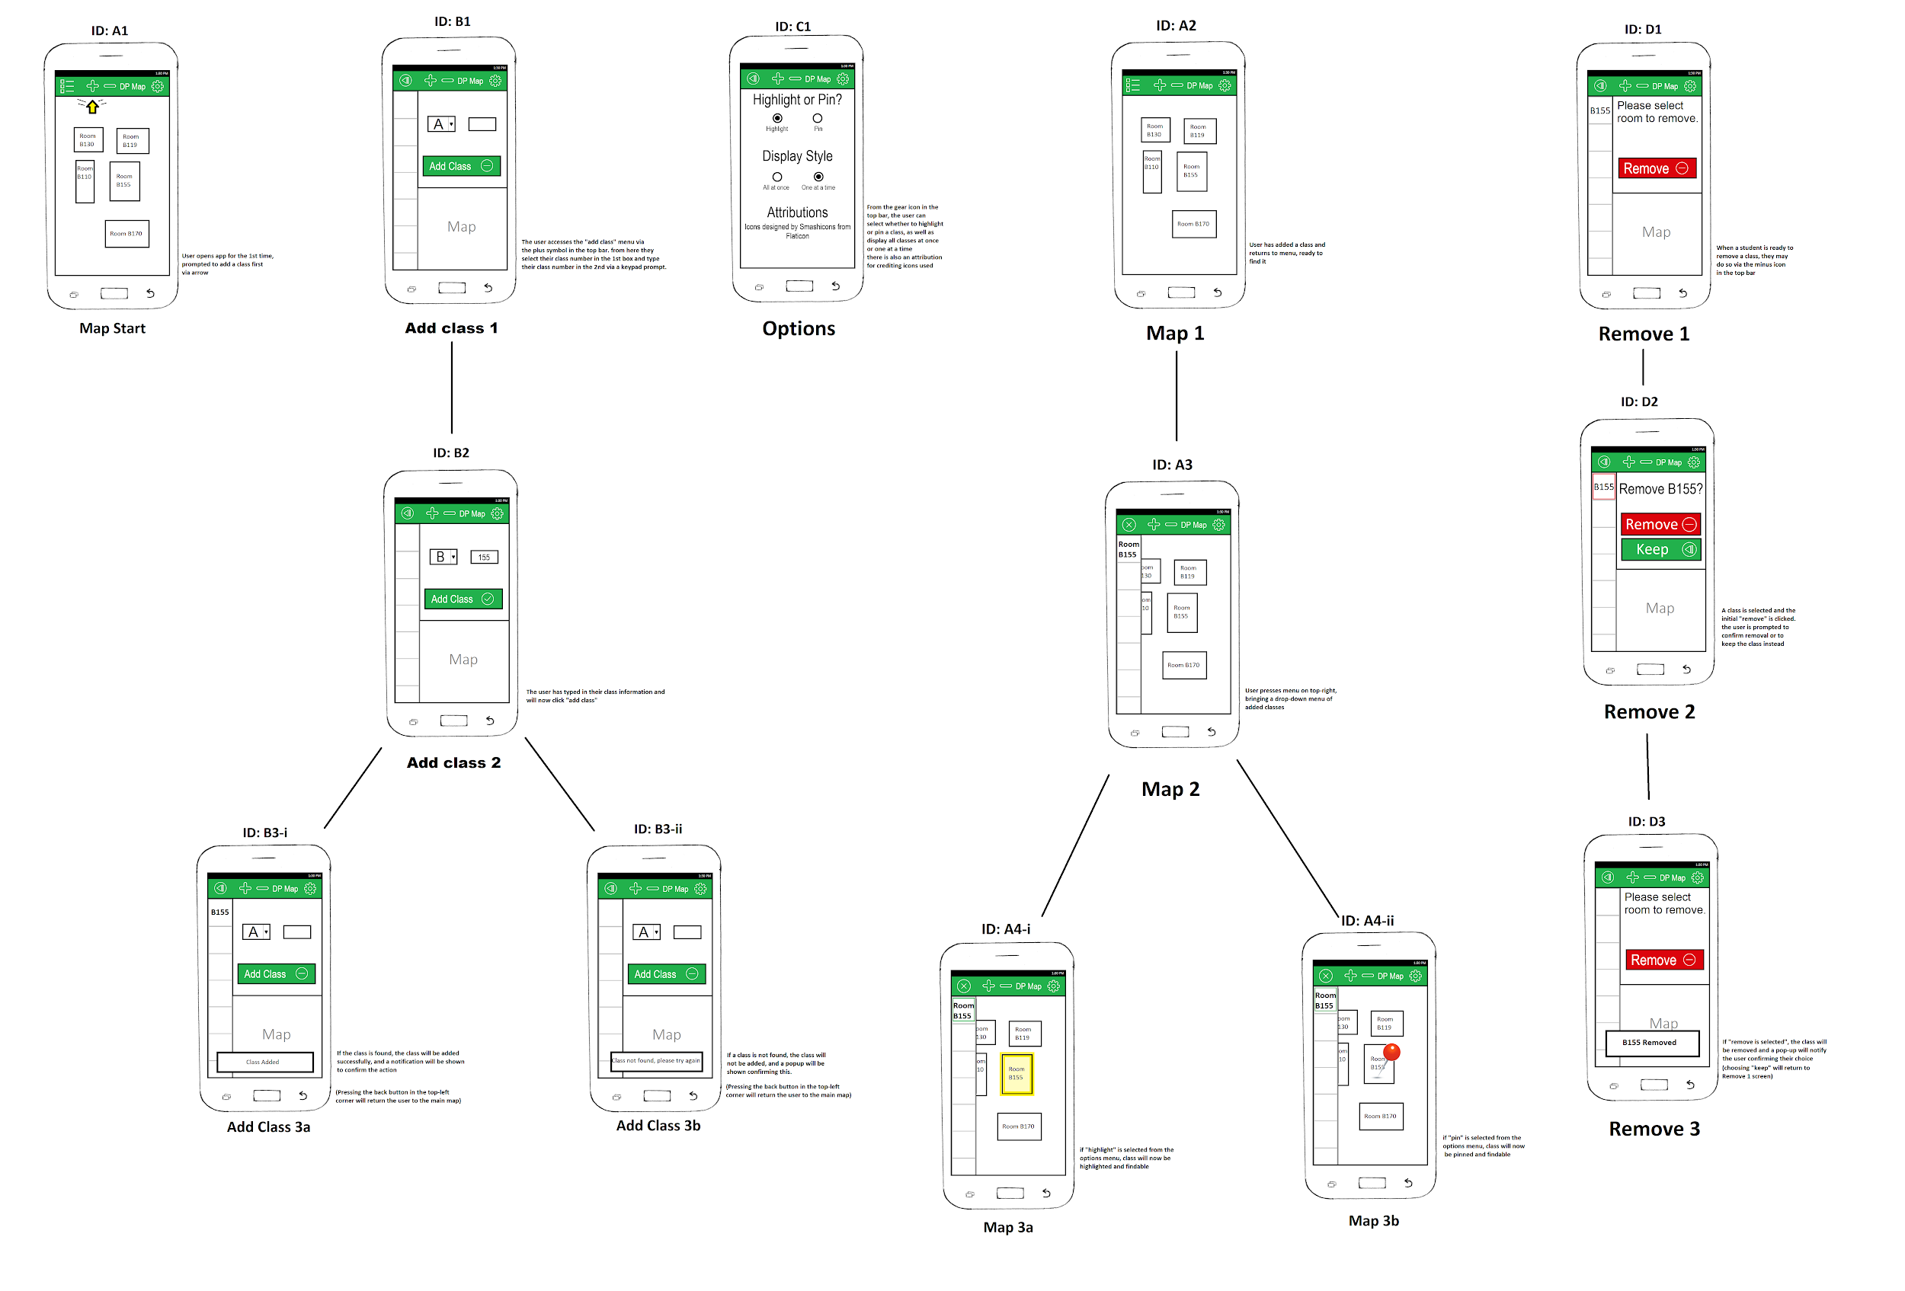

larger image: https://i.imgur.com/ZTxPs6F.jpg

Design Rationale:

We assumed that some users would try to use the app while walking to class, so whenever possible we used large buttons to make the process as easy as possible.

A.

1: The arrow was implemented in order to give the user a clear and concise direction to start from, since the design decision was made to use symbols instead of words for the three options on the top of the screen.

B.

1: Changed the on the x to a back arrow to clearly indicate a ‘return to map’ button. The cognitive walkthrough feedback said the X was too ambiguous, and they were confused what the functionality of it was since it was in the top left corner.

2: Depending on the information the user enters the add class button will display a text prompt along with a check or dash with depending on if the information has been entered at all or is in the correct format. This is done in order to let the user know when the classroom they have entered is valid (i.e. there is no B334, so attempting to locate it will not work).

C.

1: The options menu has a list of options that the user can select from. To select an option the user taps the bubble of the one they wish to select. This was done based on the assumption that the user has filled out a scantron or bubbled list before and knows that the shaded in bubble is the option the user wishes to select. There is also an attributions section which credits icons being used in the app.

A2-4.

1: The user is then able view the map seeing all of their class placements depending on the option they select. The user can also pan the map using click and drag (in this case, touch and drag, since this is an Android app). This is also done with the assumption that the user has used google maps before.

2: Assuming the user has selected “single class,” the user can tap the list icon on the top-right to bring out the list, and click the icon again (now an X) to close it.   
 3. The user can now tap the room they wish to highlight or pin on the list, and said class will be shown on the map.

F.

1: If the user wishes to remove a class from the list, after entering the remove menu, they select the class from the list. The app will display a prompt to make sure the user wishes to remove the selected class. The user will be able to choose two buttons; a green button that says to keep it, and a red one that says to remove it. The colors were selected from a basic understanding that green means add, and red means remove. Once the class is removed, the user will be given a text prompt confirming this.